**ЛАБОРАТОРНАЯ РАБОТА № 7**

**СОЗДАНИЕ КЛАССОВ И РАБОТА С ОБЪЕКТАМИ**

**Цель работы:** получить основные понятия и навыки по созданию классов, описанию свойств и работы с объектами.

**Листинг**

package org.example;  
  
import java.util.List;  
import java.util.Set;  
  
public class Main {  
 public static void main(String[] args) {  
 Library library = new Library("My_labrary");  
  
 Department department1 = new Department("Отдел 1",library);  
 Department department2 = new Department("Отдел 2",library);  
 Department department3 = new Department("Отдел 3",library);  
  
 library.addDepartment(department1);  
 library.addDepartment(department3);  
  
 Edition edition1 = new Edition("Москва", "Анастасия", 2003, department1);  
 Edition edition2 = new Edition("Питер", "Валерия", 2013, department1);  
 Edition edition3 = new Edition("Питер", "Анна", 2023, department2);  
 Edition edition4 = new Edition("Минск", "Кирилл", 2008, department3);  
  
 department1.addEdition(edition1);  
 department1.addEdition(edition2);  
 department2.addEdition(edition3);  
 department3.addEdition(edition4);  
  
 System.out.println("Библиотека:");  
 for (Department department : library.getDepartment()) {  
 System.out.println(department.getName() + "\nКоличество изданий: " + department.getAmount());  
 }  
  
 library.removeDepartment(department2);  
  
 System.out.println("Библиотека:");  
 for (Department department : library.getDepartment()) {  
 System.out.println(department.getName() + "\nКоличество изданий: " + department.getAmount());  
 }  
  
 int findYear = 2003;  
 List<Edition> foundEdition = library.findEdition(findYear);  
  
 System.out.println("\nИздания по году " + findYear + "\n");  
 for (Edition edition : foundEdition) {  
 System.out.println(edition.getName() + " " + edition.getDepartment().getName());  
 }  
 }  
}

package org.example;

import java.util.ArrayList;

import java.util.HashSet;

import java.util.List;

import java.util.Set;

public class Library {

private String name;

private Set<Department> departments;

public Library(String name) {

this.name = name;

this.departments = new HashSet<>();

}

public String getName() {

return name;

}

public void setName(String name) {

this.name = name;

}

public Set<Department> getDepartment() {

return departments;

}

public void addDepartment(Department department) {

departments.add(department);

}

public void removeDepartment(Department department) {

departments.remove(department);

}

public List<Edition> findEdition(int year){

List<Edition> editions = new ArrayList<>();

for(Department department: departments){

for(Edition edition: department.getEditions()){

if(edition.getYear() == year){

editions.add(edition);

return editions;

}

}

}

return null;

}

}

package org.example;

public class Edition {

private String name;

private String author;

private Integer year;

private Department department;

public Edition(String name, String author, Integer year, Department department) {

this.name = name;

this.author = author;

this.year = year;

this.department = department;

}

public String getName() {

return name;

}

public void setName(String name) {

this.name = name;

}

public String getAuthor() {

return author;

}

public void setAuthor(String author) {

this.author = author;

}

public Department getDepartment() {

return department;

}

public int getYear() {

return year;

}

}

package org.example;

import java.util.HashSet;

import java.util.Set;

public class Department {

private String name;

private Integer amount;

private Library library;

private Set<Edition> editions;

public Department(String name, Library library) {

this.name = name;

this.library = library;

this.editions = new HashSet<>();

}

public Library getLibrary() {

return library;

}

public void setLibrary(Library library) {

this.library = library;

}

public String getName() {

return name;

}

public void setName(String name) {

this.name = name;

}

public void addEdition(Edition edition) {

editions.add(edition);

}

public void removeEdition(Edition edition) {

editions.remove(edition);

}

public Set<Edition> getEditions() {

return editions;

}

public int getAmount(){

return amount = editions.size();

}

}

**Результат выполнения работы**

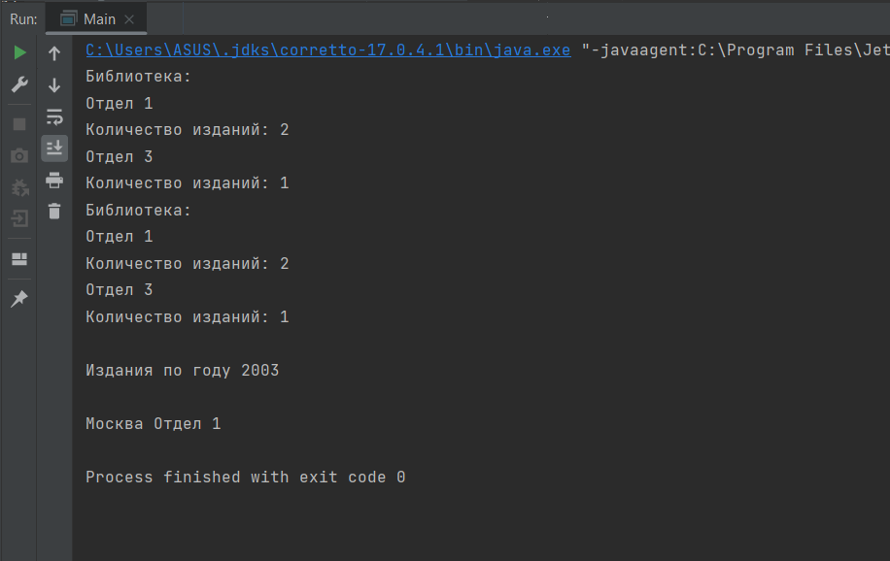

Рисунок 1 – Результат выполнения лабораторной работы

Составим диаграмму классов (рисунок 2).

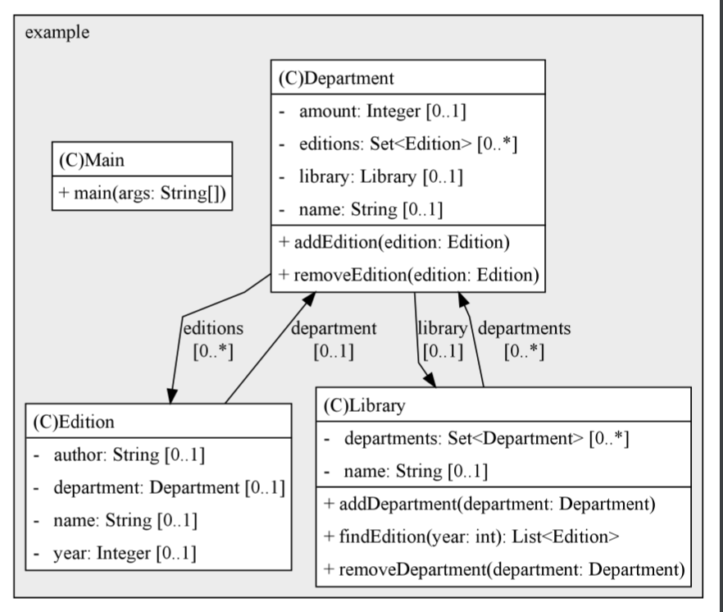

Рисунок 2 – Диаграмма классов